Fair Housing
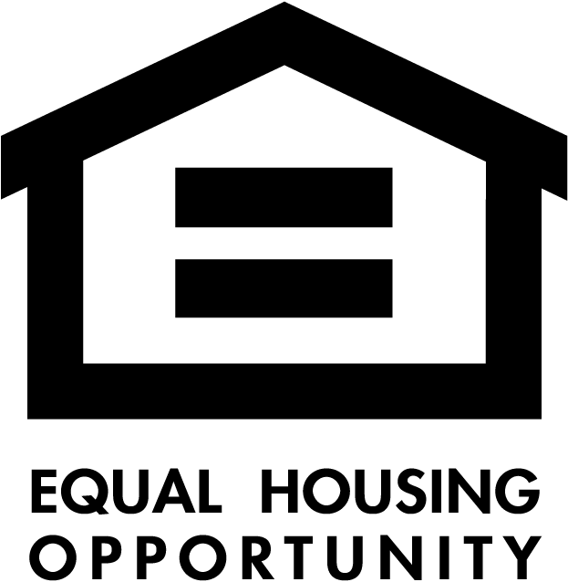

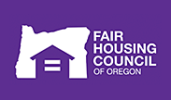
It is the policy of the City of Vale to provide, within constitutional limitations, for fair housing throughout the City of Vale for all residents.
The federal Fair Housing Act protects your right to rent an apartment, buy a home, obtain a mortgage, or purchase homeowners insurance free from discrimination based on:
• Race
• Color
• Religion
• Gender
• National Origin
• Disability (mental and physical)
• Familial Status (presence of children under 18 in the home)
Links to Fair Housing Enforcement and Education Agencies:
U.S. Department of Housing and Urban Development: Fair Housing and Equal Opportunity https://portal.hud.gov/hudportal/HUD?src=/program_offices/fair_housing_equal_opp
Oregon Housing and Community Services (Public Housing Authority of Oregon) http://www.oregon.gov/OHCS/pages/index.aspx
Fair Housing Council of Oregon (Includes Legal Aid Assistance) http://www.fhco.org/
National Association of Realtors – Fair Housing Program http://www.realtor.org/programs/fair-housing-program
Fair Housing Initiatives Program http://portal.hud.gov/hudportal/HUDsrc=/program_offices/fair_housing_equal_opp/partners/FHIP/fhip
Fair Housing Act http://www.justice.gov/crt//about/hce/title8.php
National Fair Housing Alliance http://www.nationalfairhousing.org/
FDIC Compliance with Fair Housing https://www.fdic.gov/regulations/laws/rules/2000-6000.html#fdic2000part338
The Fair Housing Council of Oregon (FHCO) is a statewide non-profit organization that provides a wide range of resources to communities. They promote equal housing by providing education, outreach, technical assistance, and enforcement opportunities. Their contact information is:
Fair Housing Council of Oregon
506 SW 6th Ave, Ste 1111
Portland, OR 97204
Phone: (503) 223-8295, (800) 424-3247
Email: information@fhco.org

